**Functions and views**

|  |  |
| --- | --- |
| **package** com.company.model;  **import** com.company.Artists;  **import** java.sql.*; **import** java.util.ArrayList; **import** java.util.List;  **public class** Datasourse {   **public static final** String ***DB_NAME*** = **"music.db"**;   **public static final** String ***CONNECTION_STRING*** = **"jdbc:sqlite:C:\\javadb\\"** + ***DB_NAME***;   *//column from database comes by a perticular order* **public static final** String ***TABLE_ALBUMS*** = **"albums"**;  **public static final** String ***COLUMN_ALBUM_ID*** = **"_id"**;  **public static final** String ***COLUMN_ALBUM_NAME*** = **"name"**;  **public static final** String ***COLUMN_ALBUM_ARTIST*** = **"artist"**;   **public static final** String ***TABLE_ARTISTS*** = **"artists"**;  **public static final** String ***COLUMN_ARTIST_ID*** = **"_id"**;  **public static final** String ***COLUMN_ARTIST_NAME*** = **"name"**;    **public static final** String ***TABLE_SONGS*** = **"songs"**;  **public static final** String ***COLUMN_SONG_TRACK*** = **"track"**;  **public static final** String ***COLUMN_SONG_TITLE*** = **"title"**;  **public static final** String ***COLUMN_SONG_ALBUM*** = **"album"**;    **private static** Connection *conn*; *//make it static else you gonna get error* **public boolean** open() {  **try** {  *conn* = DriverManager.*getConnection*(***CONNECTION_STRING***);  **return true**;  } **catch**(SQLException e) {  System.***out***.println(**"Couldn't connect to database: "** + e.getMessage());  **return false**;  }  }   **public void** close() {  **try** {  **if**(*conn* != **null**) {  *conn*.close();  }  } **catch**(SQLException e) {  System.***out***.println(**"Couldn't close connection: "** + e.getMessage());  }  }   **public void** getcount() {  String sql = **"SELECT COUNT(*), MIN(_id) FROM "** + ***TABLE_SONGS***;   **try** (Statement statement = *conn*.createStatement();  ResultSet results = statement.executeQuery(sql)) { 🡺🡺🡺🡺🡺🡺🡺🡺🡺🡺🡺🡺🡺  **int** count = results.getInt(1);  **int** min = results.getInt(2);  System.***out***.println(count);  System.***out***.println(min);  System.***out***.println();  } **catch**(SQLException e) {  System.***out***.println(**"Query failed: "** + e.getMessage());  }  } } | **package** com.company;  **import** com.company.model.Datasourse; **import** java.util.List; **import** com.company.model.SongArtist; **public class** Main {   **public static void** main(String[] args) {  Datasourse d = **new** Datasourse();  **if**(!d.open()) {  System.***out***.println(**"Can't open d"**);  **return**;  }   d.getcount();   d.close();  } }  **\*.*.*.*.*.*.*.*.*…..**  **5351**  **1**  **public void** getcount() {  String sql = **"SELECT COUNT(*) as countn, MIN(_id) as min FROM "** + ***TABLE_SONGS***;   **try** (Statement statement = *conn*.createStatement();  ResultSet results = statement.executeQuery(sql)) {   **int** count = results.getInt(**"countn"**);  **int** min = results.getInt(**"min"**);  System.***out***.println(count);  System.***out***.println(min);  System.***out***.println();  } **catch**(SQLException e) {  System.***out***.println(**"Query failed: "** + e.getMessage());  } } |

**Views**

|  |  |
| --- | --- |
| **package** com.company;  **import** com.company.model.Datasourse; **import** java.util.List; **import** com.company.model.SongArtist; **public class** Main {   **public static void** main(String[] args) {  Datasourse d = **new** Datasourse();  **if**(!d.open()) {  System.***out***.println(**"Can't open d"**);  **return**;  }   d.createViewForSongArtists();   d.close();  } } | **package** com.company.model; **import** com.company.Artists; **import** java.sql.*; **import** java.util.ArrayList; **import** java.util.List;  **public class** Datasourse {  **public static final** String ***DB_NAME*** = **"music.db"**;  **public static final** String ***CONNECTION_STRING*** = **"jdbc:sqlite:C:\\javadb\\"** + ***DB_NAME***;  *//column from database comes by a perticular order* **public static final** String ***TABLE_ALBUMS*** = **"albums"**;  **public static final** String ***COLUMN_ALBUM_ID*** = **"_id"**;  **public static final** String ***COLUMN_ALBUM_NAME*** = **"name"**;  **public static final** String ***COLUMN_ALBUM_ARTIST*** = **"artist"**;   **public static final** String ***TABLE_ARTISTS*** = **"artists"**;  **public static final** String ***COLUMN_ARTIST_ID*** = **"_id"**;  **public static final** String ***COLUMN_ARTIST_NAME*** = **"name"**;   **public static final** String ***TABLE_SONGS*** = **"songs"**;  **public static final** String ***COLUMN_SONG_TRACK*** = **"track"**;  **public static final** String ***COLUMN_SONG_TITLE*** = **"title"**;  **public static final** String ***COLUMN_SONG_ALBUM*** = **"album"**;    **public static final** String ***TABLE_ARTIST_SONG_VIEW*** = **"artist_list"**;   **public static final** String ***CREATE_ARTIST_FOR_SONG_VIEW*** = **"CREATE VIEW IF NOT EXISTS "** +  ***TABLE_ARTIST_SONG_VIEW*** + **" AS SELECT "** + ***TABLE_ARTISTS*** + **"."** + ***COLUMN_ARTIST_NAME*** + **", "** +  ***TABLE_ALBUMS*** + **"."** + ***COLUMN_ALBUM_NAME*** + **" AS "** + ***COLUMN_SONG_ALBUM*** + **", "** +  ***TABLE_SONGS*** + **"."** + ***COLUMN_SONG_TRACK*** + **", "** + ***TABLE_SONGS*** + **"."** + ***COLUMN_SONG_TITLE*** +  **" FROM "** + ***TABLE_SONGS*** +  **" INNER JOIN "** + ***TABLE_ALBUMS*** + **" ON "** + ***TABLE_SONGS*** +  **"."** + ***COLUMN_SONG_ALBUM*** + **" = "** + ***TABLE_ALBUMS*** + **"."** + ***COLUMN_ALBUM_ID*** +  **" INNER JOIN "** + ***TABLE_ARTISTS*** + **" ON "** + ***TABLE_ALBUMS*** + **"."** + ***COLUMN_ALBUM_ARTIST*** +  **" = "** + ***TABLE_ARTISTS*** + **"."** + ***COLUMN_ARTIST_ID*** +  **" ORDER BY "** +  ***TABLE_ARTISTS*** + **"."** + ***COLUMN_ARTIST_NAME*** + **", "** +  ***TABLE_ALBUMS*** + **"."** + ***COLUMN_ALBUM_NAME*** + **", "** +  ***TABLE_SONGS*** + **"."** + ***COLUMN_SONG_TRACK***;   **private static** Connection *conn*; *//make it static else you gonna get error* **public boolean** open() {  **try** {  *conn* = DriverManager.*getConnection*(***CONNECTION_STRING***);  **return true**;  } **catch**(SQLException e) {  System.***out***.println(**"Couldn't connect to database: "** + e.getMessage());  **return false**;  }  }   **public void** close() {  **try** {  **if**(*conn* != **null**) {  *conn*.close();  }  } **catch**(SQLException e) {  System.***out***.println(**"Couldn't close connection: "** + e.getMessage());  }  }   **public boolean** createViewForSongArtists() {   **try**(Statement statement = *conn*.createStatement()) {   statement.execute(***CREATE_ARTIST_FOR_SONG_VIEW***);  **return true**;   } **catch**(SQLException e) {  System.***out***.println(**"Create View failed: "** + e.getMessage());  **return false**;  }  } } |

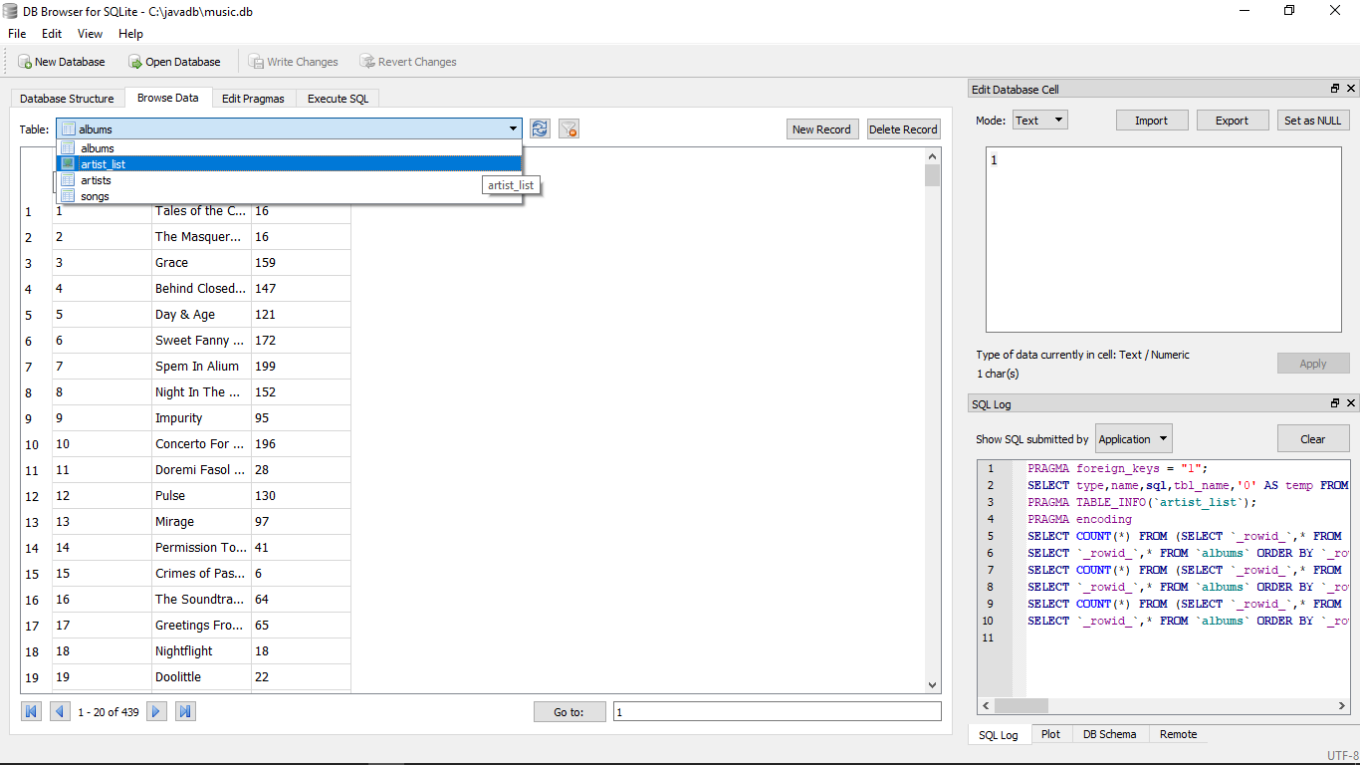

**The view is created named : artists_list**